EV SAN certificate
# Source: AI Source: Provided by: [Data Path: Persons Table -> ID Column: 1, Name_En Column: Motasem Essam] -> From: [ChatGPT] on [1/18/2026]
An EV SAN certificate is an Extended Validation (EV) SSL/TLS certificate that can secure multiple specific domains using Subject Alternative Names (SANs), while providing the highest level of identity verification.
Unlike wildcards, EV requires explicit domain verification, so all domains must be listed individually.

🔐 What EV SAN Means
# Source: AI Source: Provided by: [Data Path: Persons Table -> ID Column: 1, Name_En Column: Motasem Essam] -> From: [ChatGPT] on [1/18/2026]
- EV (Extended Validation) → verifies the legal existence of the organization and confirms the authority of the requester
- SAN (Subject Alternative Name) → allows multiple domains or subdomains to be included in a single certificate
- Provides maximum trust for users visiting the site
Example SAN List
www.example.com
api.example.com
secure.example.org
shop.example.net
All domains are covered, and the certificate shows the verified organization name.

🛠️ How It Works
# Source: AI Source: Provided by: [Data Path: Persons Table -> ID Column: 1, Name_En Column: Motasem Essam] -> From: [ChatGPT] on [1/18/2026]
- CA verifies domain ownership for each SAN entry
- CA verifies organization identity rigorously:
  - Legal registration
  - Physical address
  - Operational existence
  - Authority of the certificate requester
- CA issues the certificate listing all SAN domains
- Browsers display the verified organization information
⏱️ Issuance time: Typically a few days

📍 Where EV SAN Certificates Are Used
# Source: AI Source: Provided by: [Data Path: Persons Table -> ID Column: 1, Name_En Column: Motasem Essam] -> From: [ChatGPT] on [1/18/2026]
- Banks and financial institutions
- Payment gateways and e-commerce platforms
- Enterprise portals and SaaS applications
- Government websites
- Any website handling sensitive user data where trust is critical

✅ Advantages
# Source: AI Source: Provided by: [Data Path: Persons Table -> ID Column: 1, Name_En Column: Motasem Essam] -> From: [ChatGPT] on [1/18/2026]
- Highest level of identity assurance
- Covers multiple domains in a single certificate
- Protects against phishing and impersonation
- Same strong encryption as DV and OV
- Provides trust signals to users (organization name verification)

⚠️ Limitations
# Source: AI Source: Provided by: [Data Path: Persons Table -> ID Column: 1, Name_En Column: Motasem Essam] -> From: [ChatGPT] on [1/18/2026]
- Most expensive SSL/TLS certificate type
- Longest issuance time
- All domains must be explicitly listed (no wildcards)
- Private key compromise affects all domains in the SAN

🔒 Best Practices
# Source: AI Source: Provided by: [Data Path: Persons Table -> ID Column: 1, Name_En Column: Motasem Essam] -> From: [ChatGPT] on [1/18/2026]
- Use EV SAN for high-risk or high-value domains
- Protect the private key carefully
- Limit SAN entries to necessary domains
- Renew and rotate certificates regularly

🧠 EV SAN vs OV SAN vs DV SAN
# Source: AI Source: Provided by: [Data Path: Persons Table -> ID Column: 1, Name_En Column: Motasem Essam] -> From: [ChatGPT] on [1/18/2026]
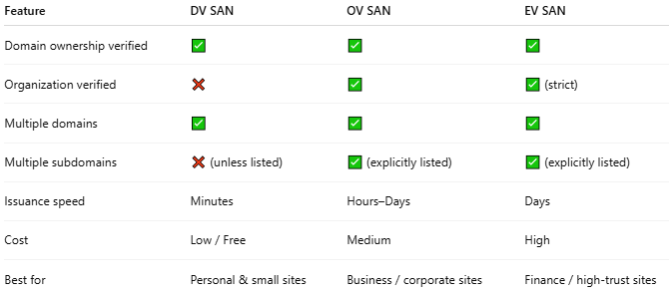
Feature | DV SAN | OV SAN | EV SAN
Domain ownership verified | ✅ | ✅ | ✅
Organization verified | ❌ | ✅ | ✅ (strict)
Multiple domains | ✅ | ✅ | ✅
Multiple subdomains | ❌ (unless listed) | ✅ (explicitly listed) | ✅ (explicitly listed)
Issuance speed | Minutes | Hours–Days | Days
Cost | Low / Free | Medium | High
Best for | Personal & small sites | Business / corporate sites | Finance / high-trust sites

One-line summary
# Source: AI Source: Provided by: [Data Path: Persons Table -> ID Column: 1, Name_En Column: Motasem Essam] -> From: [ChatGPT] on [1/18/2026]
An EV SAN certificate provides the highest trust by verifying the organization behind multiple explicitly listed domains, ideal for financial, enterprise, or high-risk websites.

